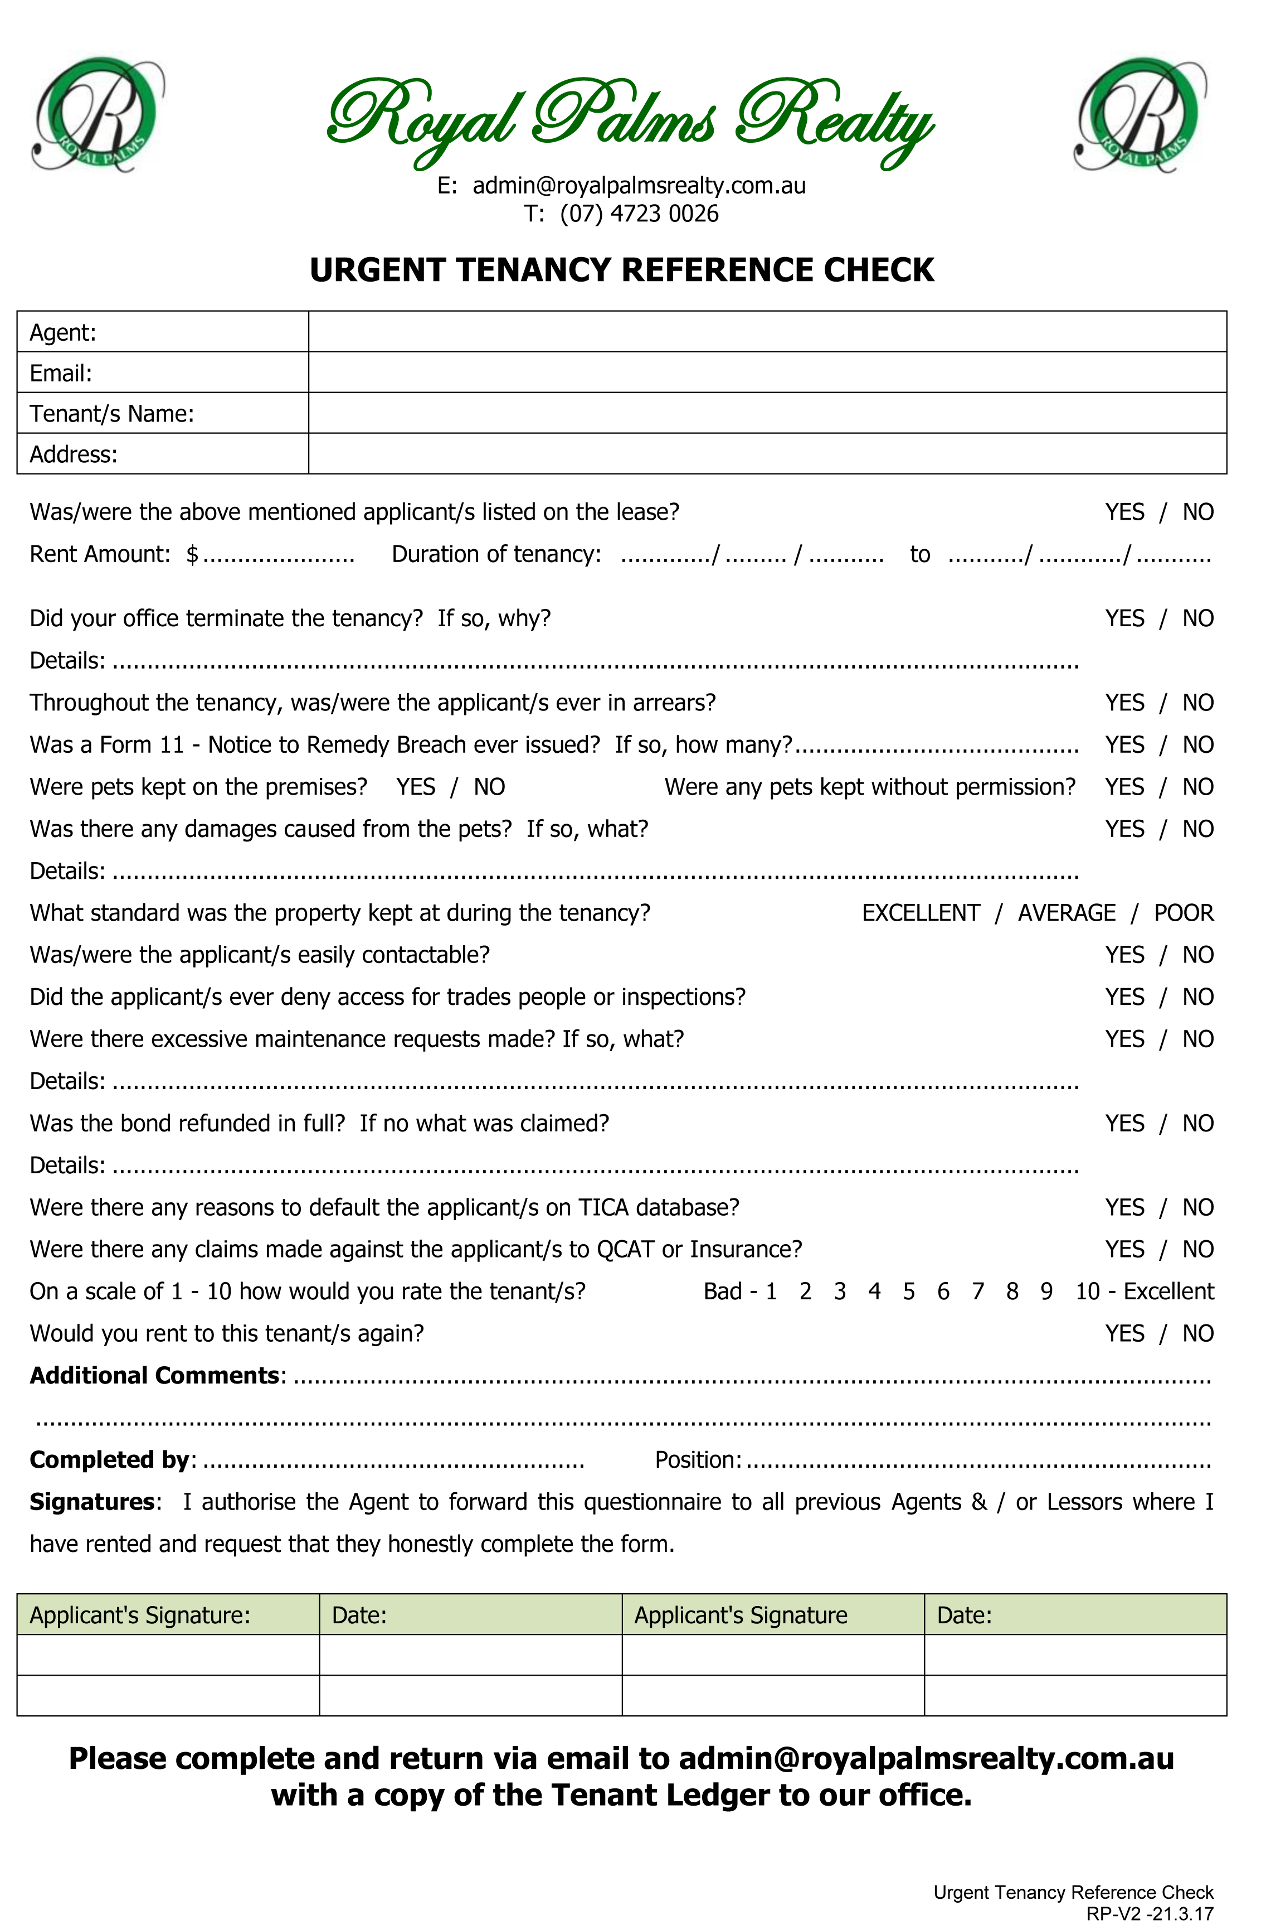 Royal Palms Realty

admin@royalpalmsrealty.com.au